**INSTRUCTIONS:**

**#Load the Library**

library(NbClust)

library(cluster)

**#K-Means**

data<- read.csv("D:/Studies/VIII Semester/R/Programs/Ex 10/Candidates.csv", header=TRUE)

head(data)

data_2<-data[-5]

head(data_2)

sapply(data,mean)

sapply(data,sd)

sapply(data_2,mean)

sapply(data_2,sd)

**# Fitting the clusters**

data_kmeans<-kmeans(data_2,centers = 2, nstart = 5)

data_kmeans$centers

data_kmeans$size

data$clstr<-data_kmeans$cluster

**# cross-validation with original species available in data**

data$clstr<-data_kmeans$cluster

fviz_cluster(data_kmeans, data = data_2)

pam.res <- pam(data_2, 2)

print(pam.res)

**# Cluster numbers**

head(pam.res$clustering)

fviz_cluster(pam.res,

palette = c("#00AFBB", "#FC4E07"), # color palette

ellipse.type = "t", # Concentration ellipse

repel = TRUE, # Avoid label overplotting (slow)

ggtheme = theme_classic())

**#K-Medoids**

**#Cluster using PAMK**

library(fpc)

data<- read.csv("D:/Studies/VIII Semester/R/Programs/Ex 10/Candidates.csv", header=TRUE)

data2<-data

data2$Name<-NULL

data2$Category<-NULL

data2$Gender<-NULL

pamk.result<-pamk(data2)

pamk.result$nc

layout(matrix(c(1,2),1,2))

plot(pamk.result$pamobject)

**#Cluster using PAM**

library(cluster)

data2<-data

data2$Name<-NULL

data2$Category<-NULL

data2$Gender<-NULL

pam.result<-pam(data2,3)

layout(matrix(c(1,2),1,2))

plot(pam.result)

**OUTPUT:**

**#K-Means**

**Head(data)**

Weight_In_Kg Height_In_CM Group Grade Category

1 78 178 2 1 IAS

2 56 198 3 3 IAS

3 89 117 1 1 IPS

4 78 157 2 2 IAS

5 85 168 3 1 IPS

6 84 178 1 3 IFS

**head(data_2)**

Weight_In_Kg Height_In_CM Group Grade

1 78 178 2 1

2 56 198 3 3

3 89 117 1 1

4 78 157 2 2

5 85 168 3 1

6 84 178 1 3

**sapply(data,mean)**

Weight_In_Kg Height_In_CM Group Grade Category

79.383838384 168.262626263 2.010101010 1.939393939 NA

**sapply(data,sd)**

Weight_In_Kg Height_In_CM Group Grade Category

11.4621890123 18.7472914281 0.8143477357 0.8058229640 0.8733437663

**sapply(data_2,mean)**

Weight_In_Kg Height_In_CM Group Grade

79.383838384 168.262626263 2.010101010 1.939393939

**sapply(data_2,sd)**

Weight_In_Kg Height_In_CM Group Grade

11.4621890123 18.7472914281 0.8143477357 0.8058229640

**# Fitting the clusters**

**data_kmeans$centers**

Weight_In_Kg Height_In_CM Group Grade

1 76.39534884 150.8837209 2.046511628 1.883720930

2 81.67857143 181.6071429 1.982142857 1.982142857

**data_kmeans$size**

[1] 43 56

**# Cross-validation with original species available in data**

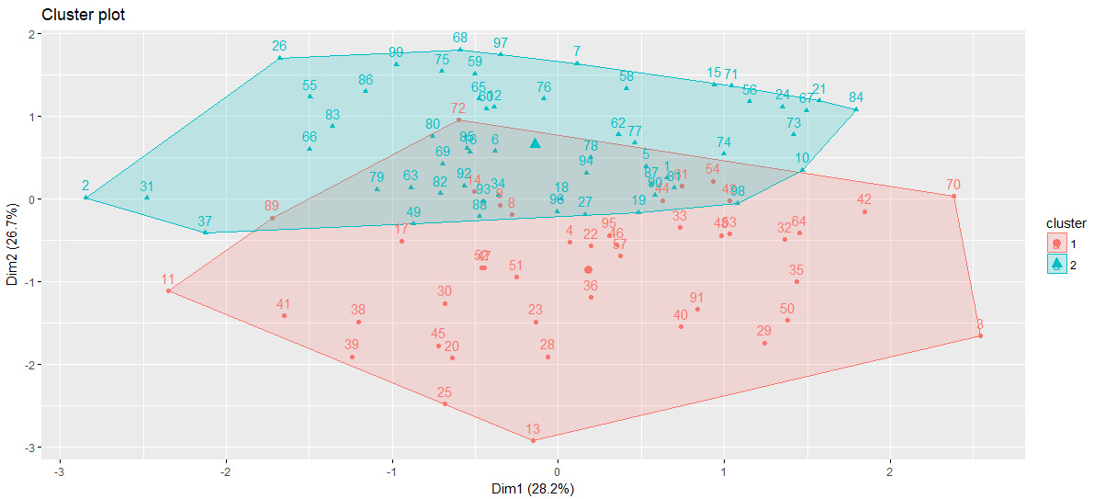

ID Weight_In_Kg Height_In_CM Group Grade

[1,] 62 83 186 1 2

[2,] 4 78 157 2 2

**Clustering vector:**

[1] 1 1 2 2 2 1 1 2 2 1 2 1 2 2 1 1 2 1 2 2 1 2 2 1 2 1 1 2 2 2 1 2 2 2 2 2 1 2 2 2 2 2 2 2 2

[46] 2 2 2 2 2 2 2 2 2 1 1 2 1 1 1 2 1 2 2 1 1 1 1 2 2 1 2 2 2 1 1 1 1 1 1 1 2 1 1 1 1 1 1 2 2

[91] 2 2 2 2 2 1 1 1 1

**Objective function:**

build swap

15.30548870 13.73281326

Available components:

[1] "medoids" "id.med" "clustering" "objective" "isolation" "clusinfo" "silinfo"

[8] "diss" "call" "data"

**# Cluster numbers**

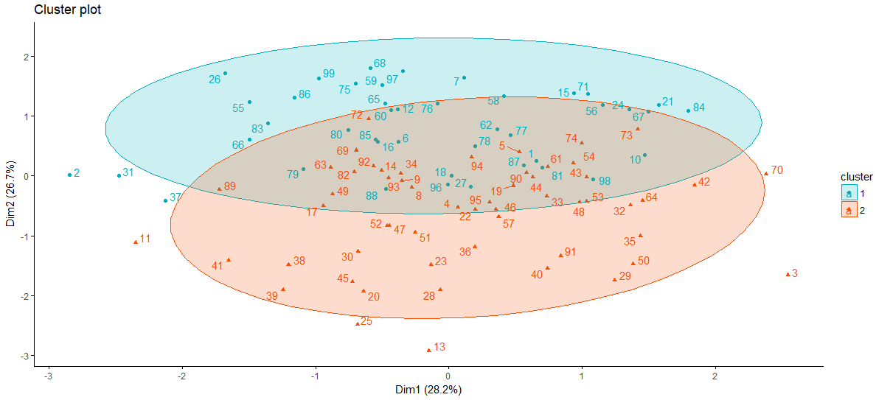

**#K-Medoids**

**#Cluster using PAMK**

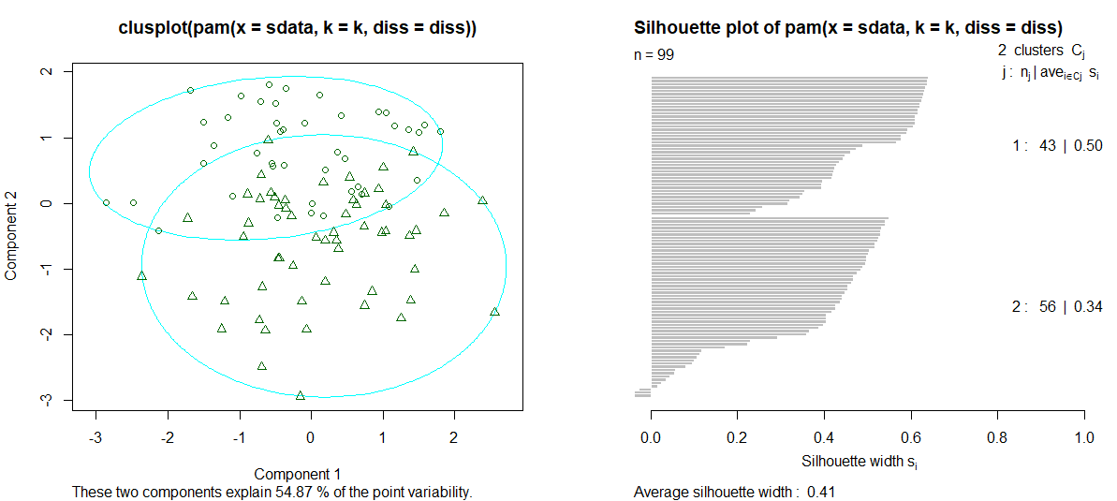

**#Cluster using PAM**

